ERTICO – ITS Europe, ITS America and ITS Asia-Pacific pact promises to take Mobility as a Service to the next level
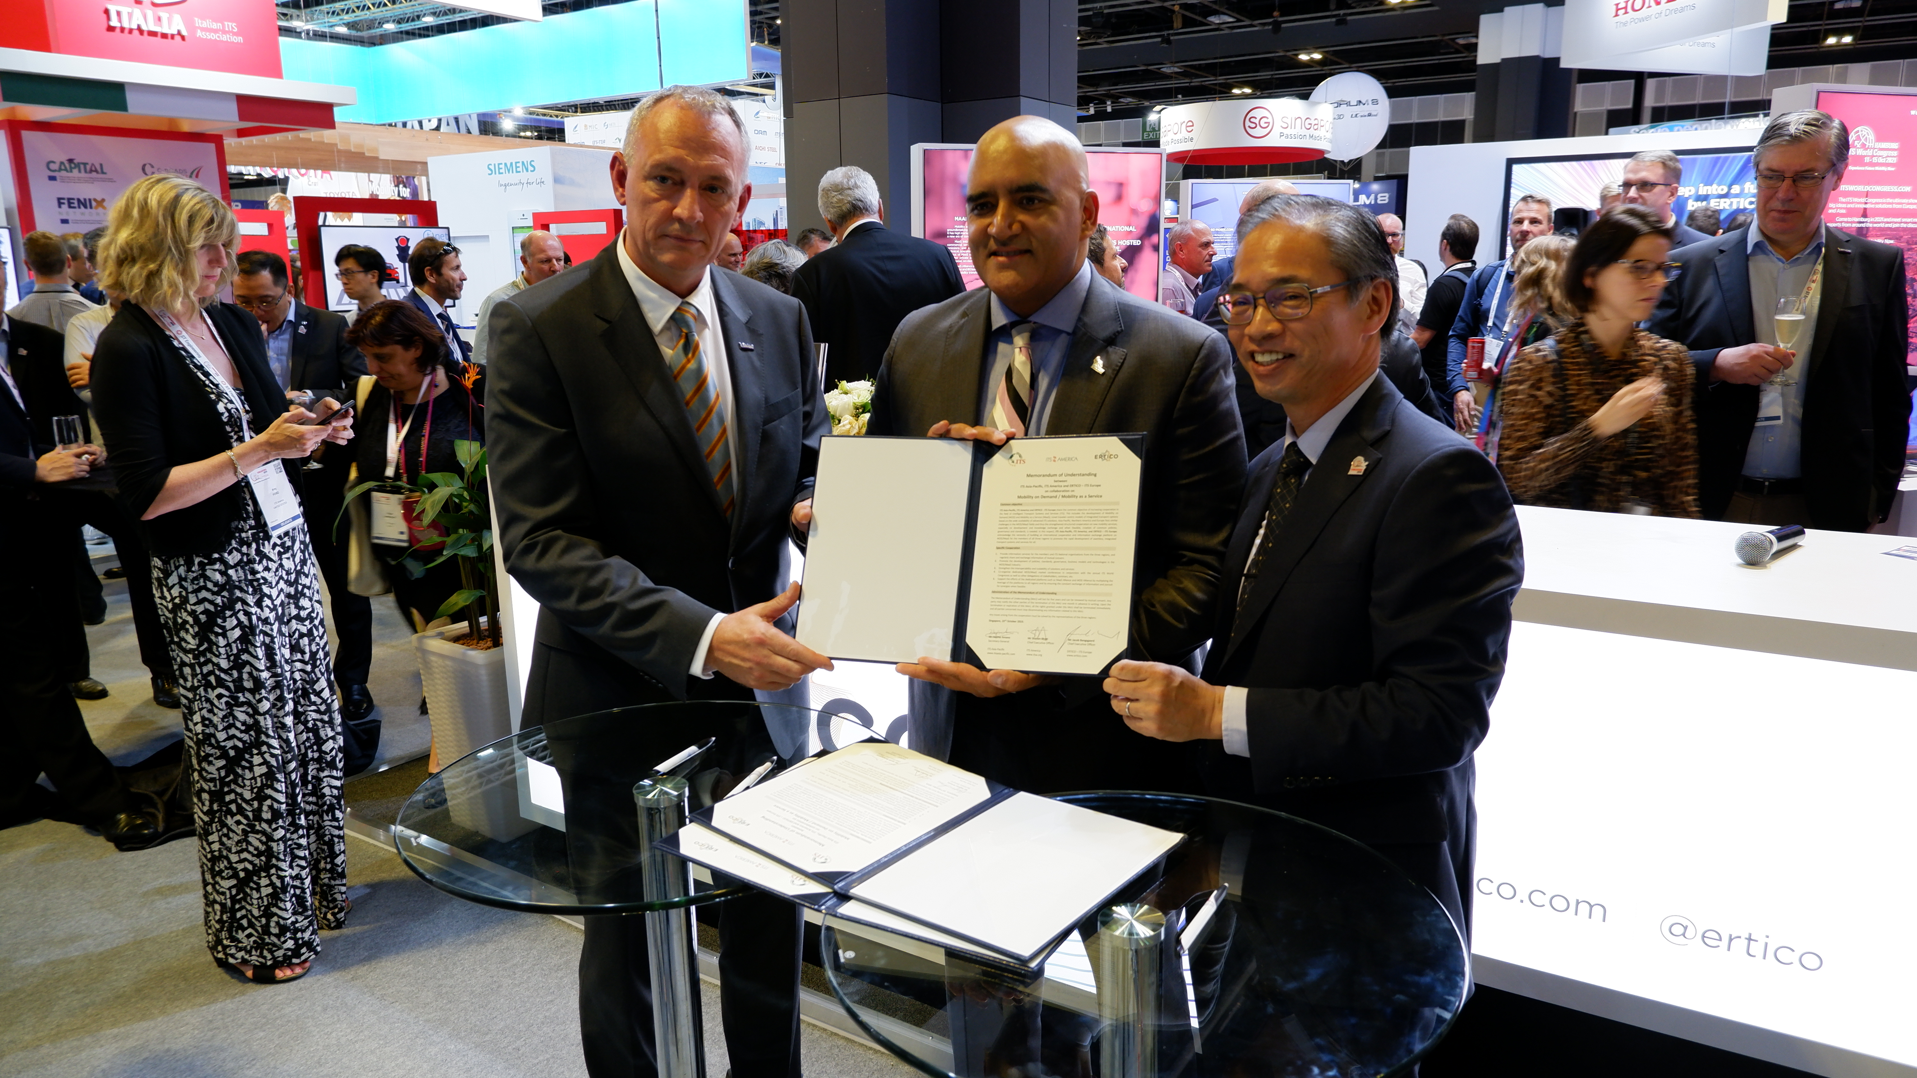

These three leading organisations in the field of intelligent mobility sign today a Memorandum of Understanding to push the rapid development of seamless, integrated transport systems and services in the three global regions.

Singapore, 23 October 2019 – Today ERTICO – ITS Europe, ITS America and ITS Asia-Pacific team-up to foster international cooperation and information exchange on Mobility on Demand (MOD) and Mobility as a Service (MaaS) for all three regions.

Jacob Bangsgaard, ERTICO CEO said: “We are pleased to continue the work on Mobility as a Service with our international colleagues from the US and excited to expand this collaboration into the Asia-Pacific region where MaaS is becoming a central theme. Regardless of the location we share the same objective to improve users’ mobility experience and services and tackle the burning challenges related to everyday mobility”.

Shailen Bhatt, President & CEO, ITS America said: “On demand mobility is transforming how people and cargo move globally. ITS America and the Mobility on Demand Alliance are looking forward to collaborating with our partners in the Asia-Pacific and Europe to focus on many of the critical issues such as data sharing, insurance, effective infrastructure and operations management, integrated trip planning and payment and others that create a more seamless mobility experience for users.”

Hajime Amano, Secretary General, ITS Asia-Pacific said: “We have a large number of mega cities in Asia-Pacific region, where growth rate is so high that transportation network is not keeping up with the pace. Efficient use of existing and emerging mobility services with MaaS is a key to mitigate mobility challenges and we have a lot to learn from European and American colleagues on technologies, policies and behavioural changes of people”.

Asia-Pacific, North America and Europe face similar challenges in MOD/MaaS developments, thus a structured cooperation on new mobility services is warmly welcomed. The Memorandum of Understanding (MoU) is a starting point for strengthening international cooperation and creating the basis for regular information exchange.

The MoU signed today promotes the development of common policies, standards, governance, business models and technologies in the MOD/MaaS industry. It also strengthens the interoperability and scalability of solutions and services. With this purpose, the three regions agree to co-organise dedicated MOD/MaaS market conferences in conjunction with the annual ITS World Congresses as well as other delegations of stakeholders, to leverage global synergies and to better understand the developments of the new business models and their applications in different environments.

